Asia-China-Coin-Southern Dynasties-H 13.18-R 10-Mould

Southern Dynasties一宋Song (420-79). Obv:太貨六餘, tài huò liù zhū (The Large Coin Six Zhu), 7.4 cm. / 2.91 in., width 8.4 cm. / 3.31 in.

H 13.18 FD 599，S 243, R 10

Issued by Emperor Xuan in 579. At first the coin was equivalent to ten Wu Zhus. Later the value was changed to one, and the contemporary saying "They cried before the Emperor, their arms akimbo" is said to refer to the discontent among the people caused by this. The seal character for 六liu suggests the arms akimbo posture. The coin was withdrawn in 582 when the Emperor died, and Wu Zhus were adopted. The Chen capital was Nanking.

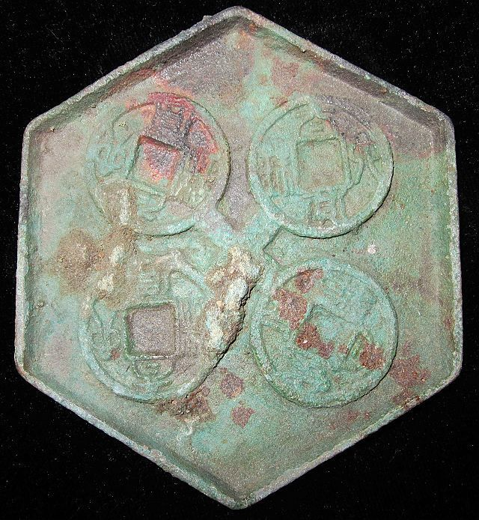

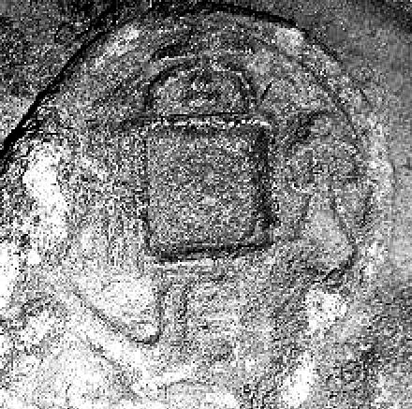

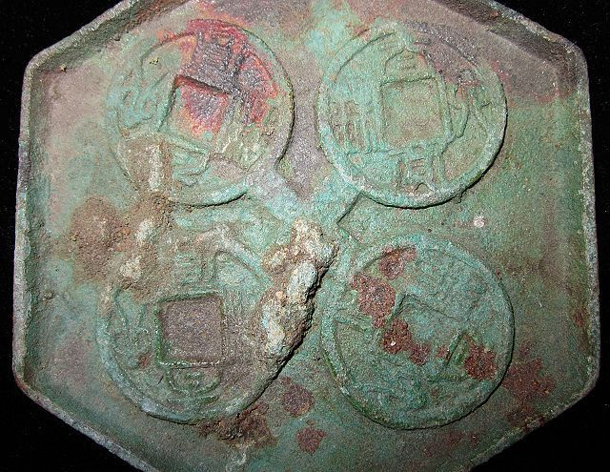 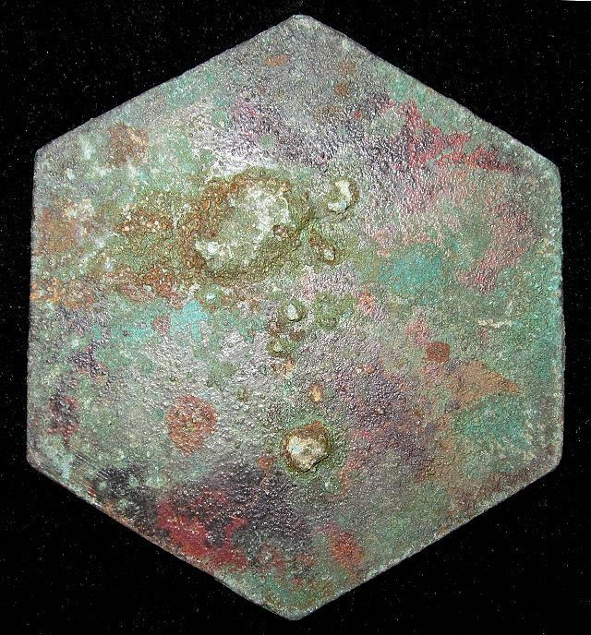

Order details Printer friendly page

Sold by

[bcculture](http://myworld.ebay.com/bcculture) ( [81](http://feedback.ebay.com/ws/eBayISAPI.dll?ViewFeedback&userid=bcculture)  )

+ Show additional actions

Delivery package 1 of 1

Estimated delivery Tuesday, Jan 21, 2014 - Tuesday, Feb 18, 2014

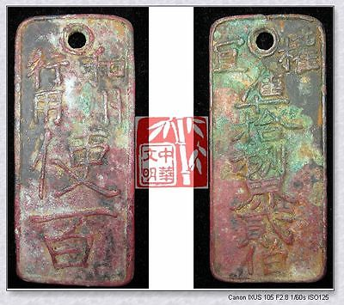

[ANTIQUE SOUTH SONG KINGDOM CURRENCY ￥100MONEY BRONZE COIN TOKEN CARD和州行用使百钱1240](http://www.ebay.com/itm/251395909770)

Item price

$49.99

Quantity

1

Item number

251395909770

Shipping service

Economy Shipping from outside US

[Leave feedback](http://feedback.ebay.com/ws/eBayISAPI.dll?LeaveFeedbackShow&useridfrom=802-867&useridto=bcculture&item=251395909770&transactid=1360749516015) [Contact seller](http://contact.ebay.com/ws/eBayISAPI.dll?FindAnswers&frm=3998&iid=251395909770&redirect=0&requested=bcculture) [Return item](http://return.ebay.com/ws/eBayISAPI.dll?ResolveReturn&eventName=viewSelectedItem&TransactionId=1360749516015&ItemId=251395909770)

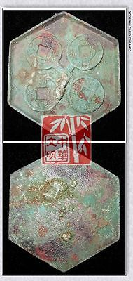

[SOUTH NORTH DYNASTY CHEN POLICY LAST MONEY MODEL BRONZE COIN PATTERN太货六铢钱范3"RARE](http://www.ebay.com/itm/251413172236)

Item price

$59.99

Quantity

1

Item number

251413172236

Shipping service

Economy Shipping from outside US

[Leave feedback](http://feedback.ebay.com/ws/eBayISAPI.dll?LeaveFeedbackShow&useridfrom=802-867&useridto=bcculture&item=251413172236&transactid=1360816867015) [Contact seller](http://contact.ebay.com/ws/eBayISAPI.dll?FindAnswers&frm=3998&iid=251413172236&redirect=0&requested=bcculture) [Return item](http://return.ebay.com/ws/eBayISAPI.dll?ResolveReturn&eventName=viewSelectedItem&TransactionId=1360816867015&ItemId=251413172236)

### Shipping address

Ralph J Coffman Jr  
149 Atlantic Ave   
Swampscott MA 01907-2427  
United States

Phone number  
781 584 7091

### Order total

Subtotal $109.98

Shipping $50.00

Shipping discount -$3.00

#### Total

## $156.98

[View PayPal transaction](http://payments.ebay.com/ws1/eBayISAPI.dll?IntermediateResolutionInfo&itemid=0&transId=0&pn=UnifiedCheckoutSummaryRedirect2PP&qs=itemid%3D0%26transId%3D0%26buyerorseller%3D0%26)

### Order information

Order placed on  
Monday, Dec 30, 2013

Having a problem with this purchase?  
[Resolve problem](http://res.ebay.com/ws/eBayISAPI.dll?ResolutionCenter)

Payment method   
PayPal

Payment date  
Monday, Dec 30, 2013

|  |
| --- |
|  |
| [Ad Feedback](javascript:void(0);)|[AdChoice **- opens in a new window or tab**](javascript:void(0);) |